**Front-End UI/UX Development**    
   
   
**Front-End UI/UX Development Mini Project**    
   
   
**UI/UX DESIGN FUNDAMENTALS**

**Submitted by:**

|  |  |  |  |  |
| --- | --- | --- | --- | --- |
| **SR.NO** | **NAME** | **REGISTER**  **NUMBER** | **COLLEGE EMAIL ID** | **CLASS** |
| 1. | SNEHA T | 2462365 | sneha.t@btech.christuniversity.in | 3BTCS DS |
| 2. | VIKASINI CHANDRAKUMAR | 2462373 | vikasini.chandrakumar@btech.christuniversity.in | 3BTCS DS |
| 3. | RAKSHWANTH.K | 2462352 | rakshwanth.k@btech.christuniversity.in | 3BTCS DS |

**Instructor Name**: Ms. Nagaveena

**Institution Name:** Christ (Deemed to be University), Bangalore

**Date of Submission:**13/08/2025

**TECH CONFERENCE EVENT PAGE**

**1.Abstract**

This project is a responsive web-based event landing page designed for a fictional "Tech Innovators Summit 2025." The primary goal of the project is to provide an interactive and informative platform where users can explore event details, view speaker profiles, check the agenda, and register for the event. Built using core front-end technologies such as HTML, CSS, the page includes modern features like a live countdown timer, sticky navigation, and a registration form. The final outcome is a clean, user-friendly event website that can adapt to different screen sizes and devices. This project demonstrates essential skills in front-end web development and serves as a practical template for organizing or promoting real-world events, making it valuable for both learning and portfolio purposes.

**2.Objectives**

* Design a visually appealing and user-friendly event page using MOD and UI principles.
* Develop a fully responsive interface using only HTML and CSS to ensure cross-device compatibility.
* Implement semantic HTML structure to clearly organize event sections like speakers, agenda, and tickets.
* Apply CSS for consistent branding, layout design, and responsive behavior without external frameworks.
* Ensure accessibility, readability, and smooth user interaction across various screen sizes and devices.

**3.Scope of The Project**

* Design and develop the front-end of the Tech Conference event landing page.
* Create a fully responsive layout for desktop, tablet, and mobile viewing.
* Use semantic HTML and CSS to structure and style event details like speakers, agenda, and registration.
* Exclude JavaScript and backend integration; focus is on static content and styling.
* Utilize only open-source tools and peer-reviewed CSS methods.
* Deliver a clean, professional, and maintainable prototype tailored for tech event promotion.

**5. Tools & Technologies Used**

|  |  |
| --- | --- |
| Tool/Technology | Purpose |
| HTML5 | Markup and content structure |
| CSS3 | Styling and layout management |
| VS Code | Code editor |
| Chrome DevTools | Testing and debugging |
| Google Fonts (Handlee) | Decorative cursive font for handwritten feel |

**6. HTML Structure Overview**

* **<header>**  
  Contains the site logo and sticky navigation menu linking to different sections.
* **<section id="hero">**  
  The hero/banner area with event title, date, location, and countdown timer.
* **<section id="about">**  
  Overview of the event’s purpose and details.
* **<section id="speakers">**  
  Profiles of keynote speakers with photos and bios.
* **<section id="agenda">**  
  Event schedule listed by day and time.
* **<section id="tickets">**  
  Ticket pricing details and the “Register Now” call-to-action button.
* **<section id="venue">**  
  Venue information including address and map image.
* **<footer>**  
  Contains copyright and additional links or contact info.

## **7. CSS Styling Strategy**

• **Mobile-First Design**: Start with styles for small screens and use media queries to adapt for larger devices.

• **Responsive Layout**: Utilize Flexbox and CSS Grid to create flexible, adaptive layouts that adjust seamlessly across devices.

• **Semantic Styling**: Apply styles to semantic HTML elements to enhance accessibility and maintain a logical content hierarchy.

• **Consistent Branding**: Define a color palette, typography, and button styles to ensure visual consistency throughout the page.

• **Minimal Dependencies**: Avoid external CSS frameworks; rely on native CSS to keep the project lightweight and customizable

**8. Key Features**

|  |  |
| --- | --- |
| Feature | Description |
| Speakers Section | Showcases profiles of keynote speakers with photos and bios to highlight expertise and attract attendees. |
| Agenda Section | |  | | --- | |  |  |  | | --- | | Lists the event schedule, including session topics and timings, to help attendees plan their participation. | |
| Responsive Design | Ensures the page is accessible and user-friendly across various devices, enhancing user experience. |
| Contact Information | Provides organizers' contact details for inquiries, building trust and offering support. |
| Footer Section | Includes copyright information, privacy policy links, and additional navigation options for comprehensive site structure. |

**9. Challenges Faced & Solutions**

|  |  |
| --- | --- |
| Challenge | Solution |
| Performance Optimization | Optimized images, minimized CSS/JS files, and utilized lazy loading to enhance load times. |
| Cross-Device Testing | Utilized tools like BrowserStack to test and ensure consistent appearance across various devic |
| User Interaction Feedback | Applied hover and focus styles to interactive elements to improve user experience. |

## **10. Outcome**

The completed Tech Conference event landing page serves as a polished, mobile‑first promotional tool, delivering critical event information and registration prompts across desktop, tablet, and mobile. Built solely with semantic HTML and CSS, it ensures accessibility, fast load times, and consistent branding without relying on JavaScript or backend integrations. The static design provides a lightweight, maintainable prototype that communicates professionalism and enhances user engagement—ideal for showcasing front‑end development capabilities.

## **11. Future Enhancements**

* **Team Toggler** — Add tabs or buttons to flip between different speaker groups (e.g., Keynotes, Panels, Workshops), improving content navigation.
* **Light/Dark Mode Toggle** — Allow users to switch between light and dark themes using CSS custom properties or prefers-color-scheme, enhancing accessibility and comfort.
* **Backend Form Integration** — Connect the registration form to a backend service or BaaS like Firebase to manage submissions and attendee data.
* **Animated Interactions** — Use CSS transitions or keyframe animations for hover effects, countdown timing, or smooth page transitions to elevate the UX.

**12. Sample Code**

index.html

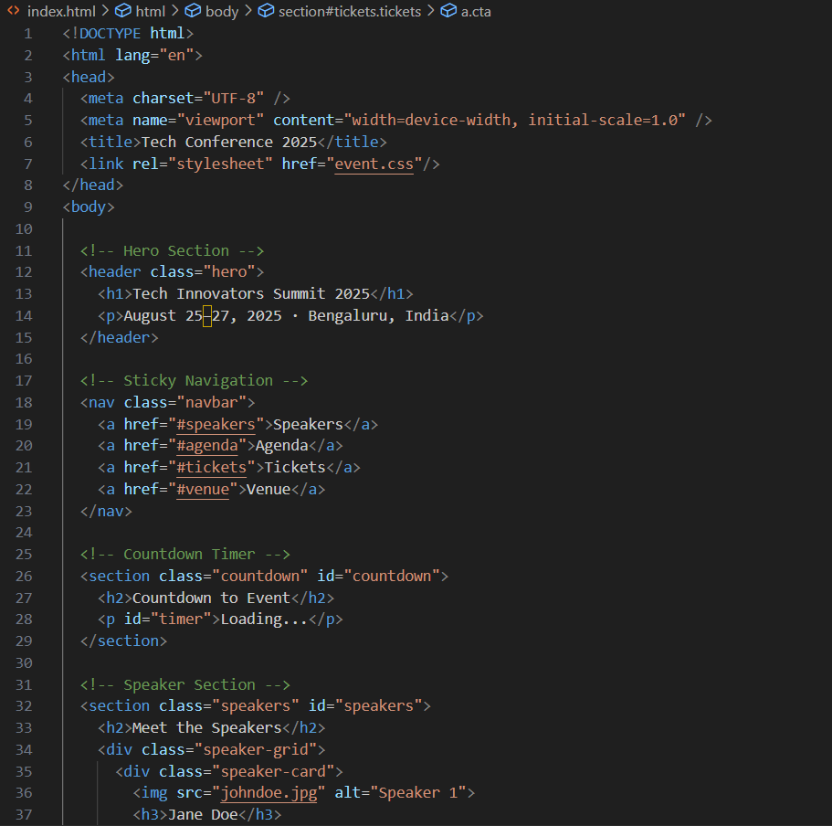

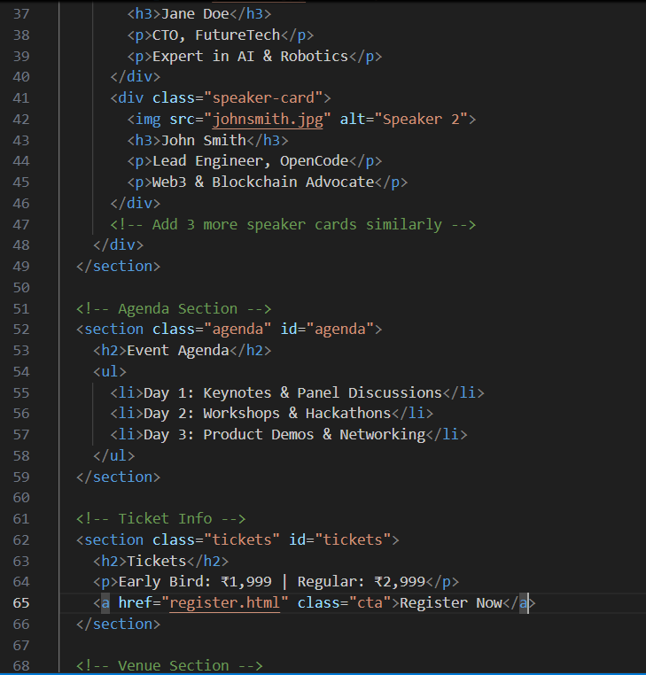

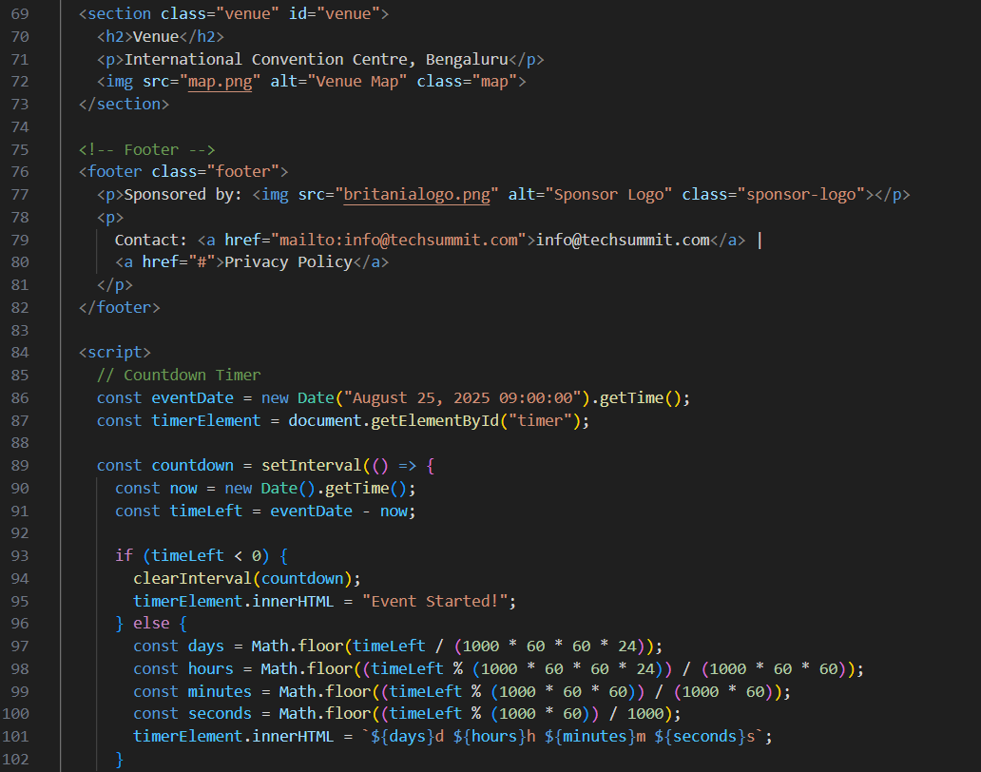

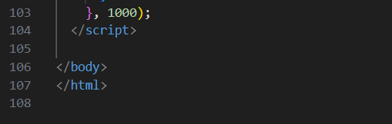

Register.html

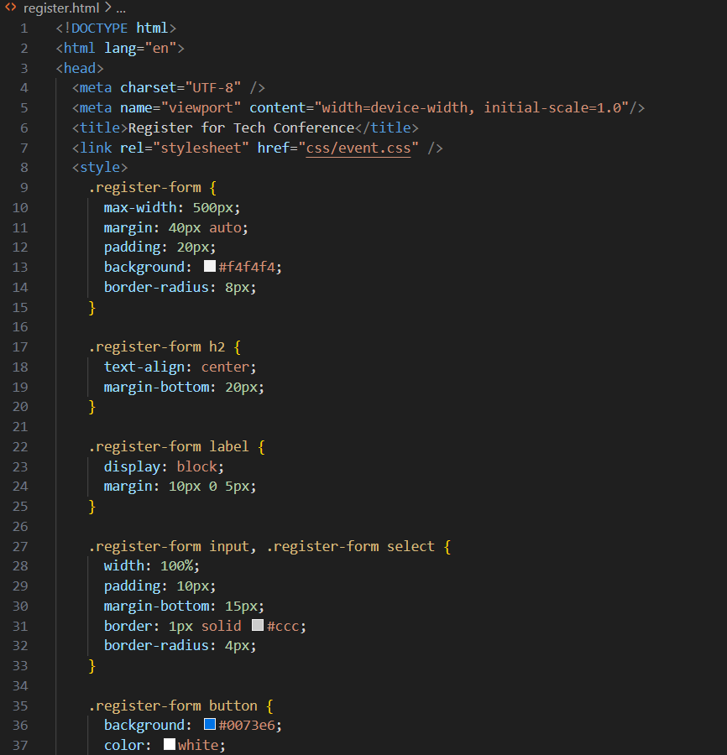

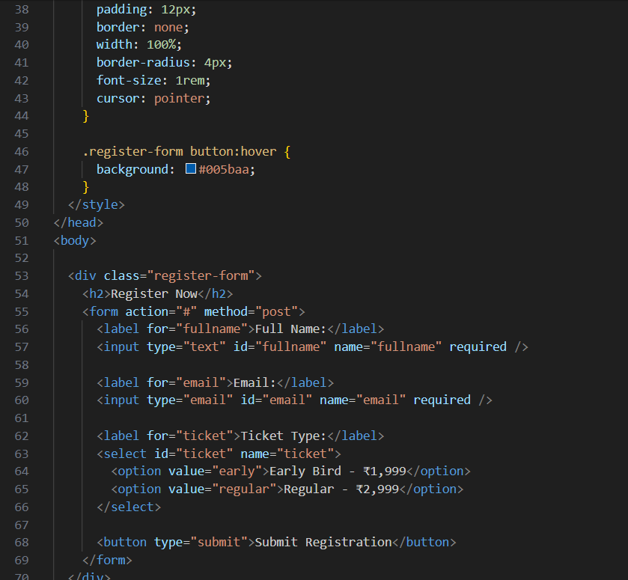

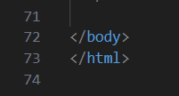

event.css

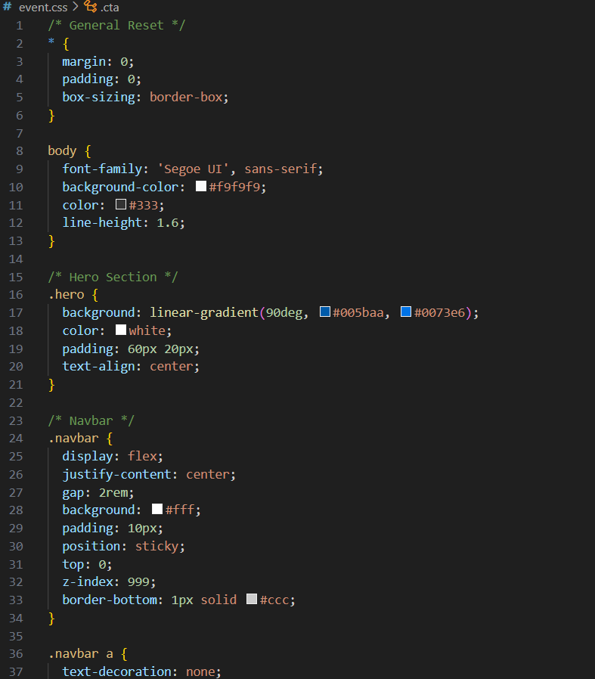

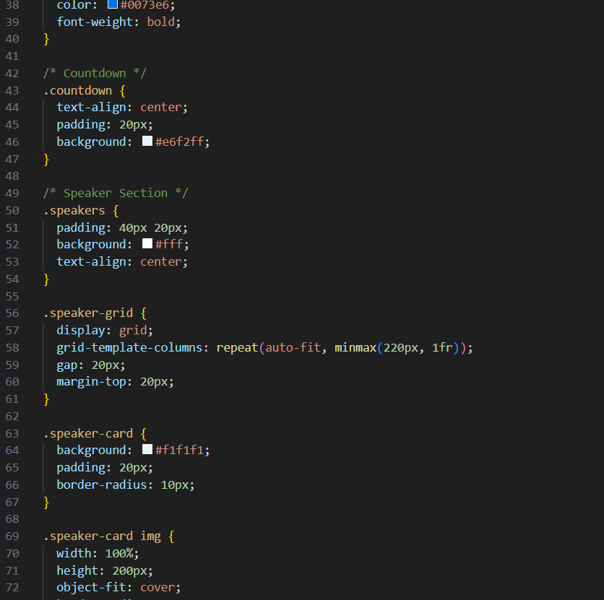

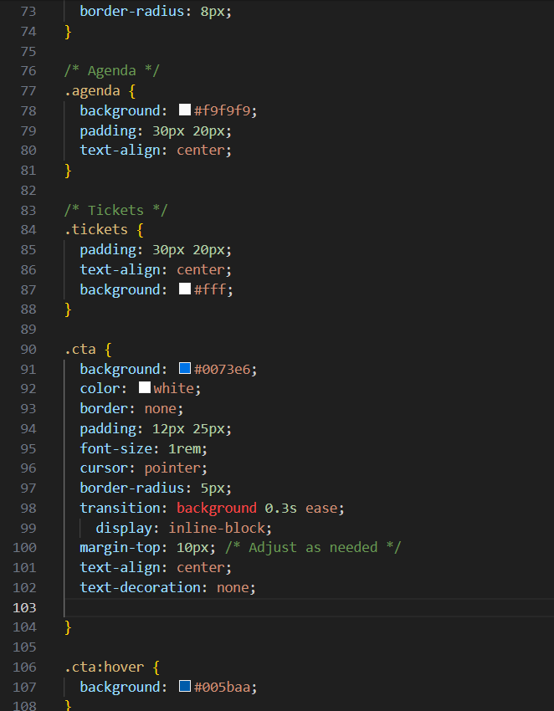

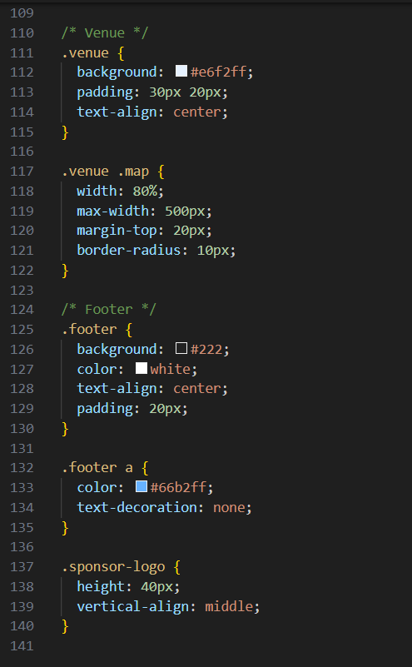

**13. Screenshots of Final Output:**

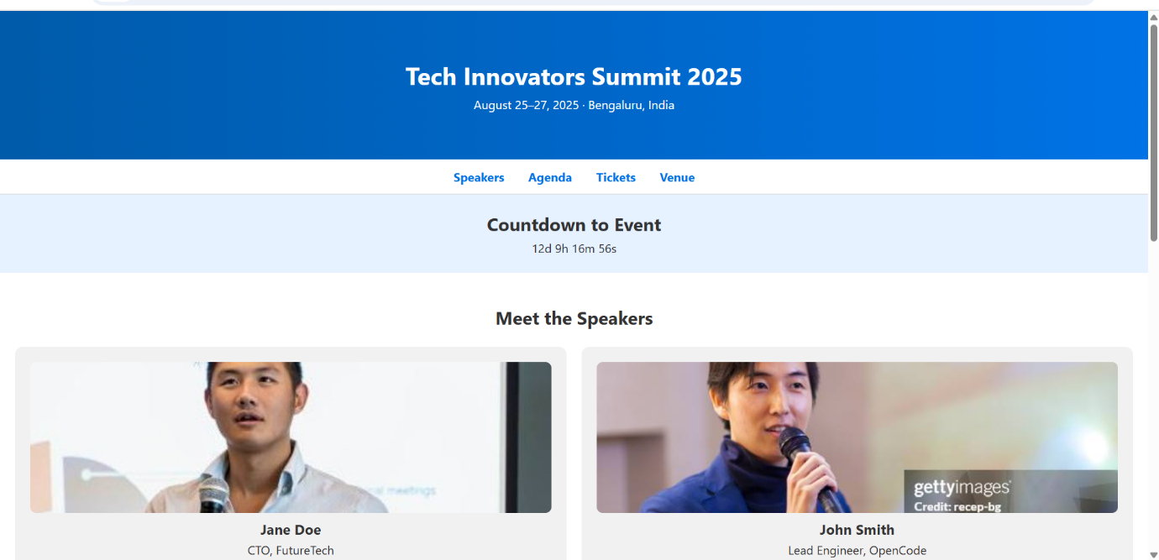

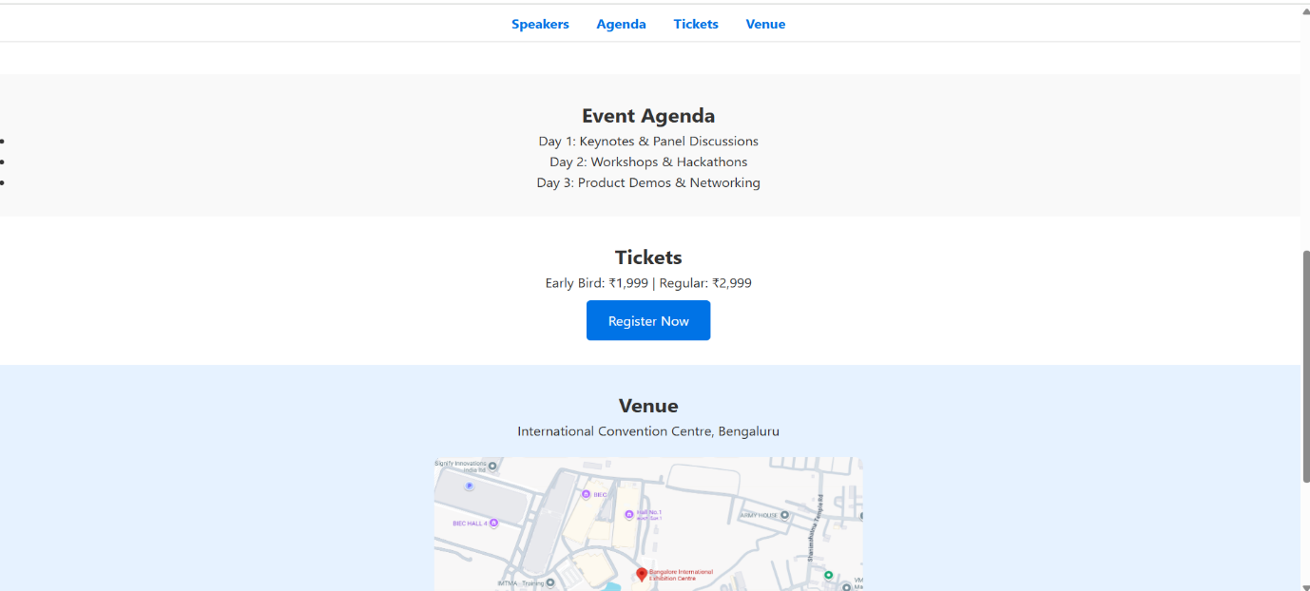

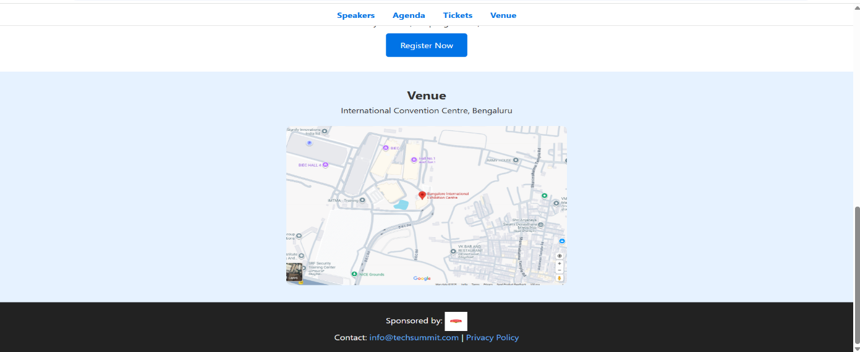

Register now page:

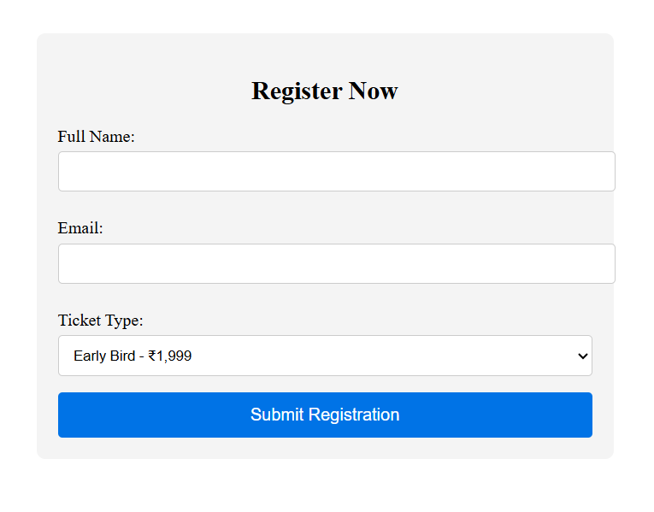

## **14. Conclusion**

This project successfully delivers a clean, fully responsive landing page for a tech conference using only semantic HTML and CSS. The design excels in usability and accessibility across desktop, tablet, and mobile views. It’s lightweight and maintainable, fulfilling key promotional and informational roles without relying on JavaScript or backend functionality.